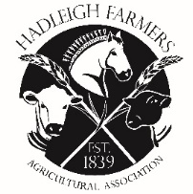 | HADLEIGH FARMERS' AGRICULTURAL ASSOCIATION  HORTICULTURAL CLASSES ENTRY FORM  HADLEIGH SHOW – SATURDAY 17th May 2025

Name
Address
Tel No
Email

Please tick classes you wish to enter.
Entries close – 12th May 2025

Class Number | Tick to enter
Class H1
Class H2
Class H3
Class H4
Class H5
Class H6
Class H7
Class H8
Class H9
Class H10
Class H11
Class H12
Class H13
Class H14
Class H15

Please return to: Mr. P Simpson, Wetherden Hall, Balls Hill, Hitcham, IP7 7PZ
Email: patrick.simpson1uk@gmail.com

